**Nddata.py**

This script processes and cleans the trip files of one subject and then concatenates them into one big subject file.

The input of the script is the subject of raw_nd_data, like ‘001’, ‘003’.

**Ndviz.py**

This script draws a map of all trips the person has had, which is made by Chris.

The input of the script is the subject of raw_nd_data, like ‘001’, ‘003’.

**Plot_accx_accy_accz.py**

This script draws the plots to compare the variable gpsspeed, accy (the one given in the raw data), and acc (the one we calculated based on gpsspeed). It generates the plots of all trips of one subject. The plot generated is **similar** to the picture below.

(Hint: in Matplotlib, blue line is the first variable you draw, green is the second, red is the third, light blue is the forth.)

The input of the script is the subject of raw_nd_data, like ‘001’, ‘003’.

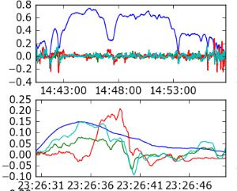

Plots comparing gpsspeed, accx, accy and accz.

**Plot_gpsspeed_obdspeed.py**

This script draws the plots to compare the variable gpsspeed and obdspeed, in order to see the difference and quality of the two variables. And we finally decided that gpsspeed is more valid than obdspeed. The plot generated is same to the picture below.

The input of the script is the subject of raw_nd_data, like ‘001’, ‘003’.

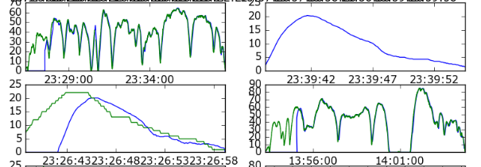

Plots comparing gpsspeed and obdspeed.

**Plot_lat_lng_reverse.py**

This script draws the map of a trip based on the variables longitude and latitude. When we detect a reversing drive, the reversing part will be red. The plot generated is same to the picture below.

The input of the script is the trip number you want to analyze, like ‘1894’, ‘1881’.

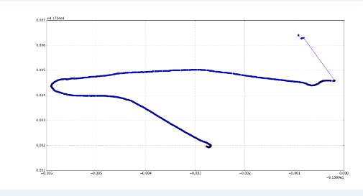

Plot of a trip using variables longitude and latitude.

**Processall.py**

This script runs all trips of the 33 subjects at a time.

The input of the script is raw_nd_data.